Covid -19 Coronavirus: SONZ Alert System Protocols
ALERT  Level 0 | ALERT  Level 1 | ALERT  Level 2 | ALERT  Level 3 | ALERT  Level 4
SCHOOL BASED ACTIVITY
All school events in place without restriction | School activity allowed | School activity allowed | Zero school activity | Zero school activity
CLUB BASED ACTIVITY
All training & events in place without restriction | Club training & events allowed to run | Club training & events as per guidelines below | Zero club activity | Zero club activity
Club meetings as usual | Club meetings as usual | Online meetings recommended | Online meetings only | Online meetings only
SONZ STAFF ACTIVITY
Staff fully operational from their workspace | Staff work out of their office but are prepared to work from home | Staff work from home with some flexibility to return to the office | Staff work from home | Staff work from home
International travel (Depending on international situation) | Domestic travel allowed | Domestic travel allowed | No travel | No travel
SONZ PROGRAMMES
YAP & ALPS in operation | YAP & ALPS in operation | YAP & ALPS Postponed | YAP & ALPS Postponed | YAP & ALPS Postponed
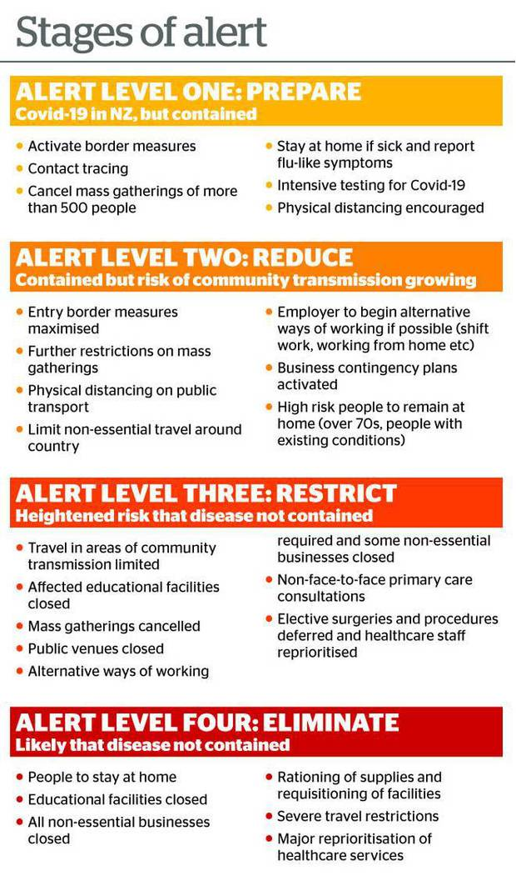
- This alert system is an evolving document and updates will be made when necessary and in alignment with the NZ Government.

- Anyone with symptoms or actual illness is required to stay home at any alert level when participating in any SONZ programme.
Covid - 19 Coronavirus: SONZ Return to Activity Guide

SPORTS | Inactivity  Duration: 2- 4 weeks | Inactivity  Duration: 5 - 7 weeks | Inactivity  Duration: 8 weeks >
 | Required number of Training Sessions Before Returning to Competition
Athletics (AT) | Two | Three | Four
Alpine Skiing (AS) | Two | Three | Four
Basketball (BB) | Two | Three | Four
Bocce (BC) | Two | Two | Three
Equestrian (EQ) | Two | Two | Four
Football (FB) | Two | Three | Four
Bowling (BO) | Two | Two | Three
Golf (GF) | Two | Two | Three
Indoor Bowls (IB) | Two | Two | Three
Powerlifting (PL) | Two | Three | Four
Swimming (SW) | Two | Three | Four
Snowboarding (SB) | Two | Three | Four
Table Tennis (TT) | Two | Two | Four
*Immediate return to competition is allowed if athletes have been inactive for two weeks or less
SONZ return to activity guide will continue to be implemented alongside the alert system protocols. This guide ensures all athletes and volunteers are supported and provided with the appropriate tools before returning to competition. Physical and social wellbeing is paramount and must be a key focus as we return to activity.
Return to Training
Whilst a return to training is not compulsory at level 2-, clubs may return at level 2 with the following restrictions:
- Your regional restriction on social gatherings is set at 50 or higher
- Contact tracing forms are completed at each training session
- Hand hygiene protocols continue to be followed and promoted by coaches
- No spectators allowed at training level 2.

SONZ also recommend:
- Athletes and volunteers wear a face mask on the way to and from training
- All coaches and volunteers wear a face mask during training where possible

Attending Events

Clubs may host and attend events at level 2 with the following restrictions:
- Recommence from Saturday 26 September 2020
- Entries to events must be from clubs that are living in an area with the same alert level restrictions as the region that the event is being held
- No spectators allowed to attend events during level 2
- Due to restrictions on public gatherings there may need to be restrictions on entries to events. The host club and RSC will work with clubs to determine the number of athlete able to attend each event.

Events at Level 2 can be confirmed following the steps below:

School Activity
School activity will resume at Level 2. In-school activity will focus on skill development, fundamental movement and getting students active and taking part in physical activity.

