How will a club know when a registration has been submitted?

When an athlete/volunteer/unified partner selects the club they are registering with, it will automatically link up to the club’s email or nominated email address. This means when a athlete/volunteer/unified partner registration is submitted all the details will be sent to this email address, including a copy of the athlete’s medical form for athlete registrations.

A copy of the volunteer/unified partner’s police vetting forms will not be included in this email.

Please note the email may appear in the spam or junk mail folder.

If you wish to change the email address, please contact Zoe at comms@specialolympics.org.nz

Each month your local RSC will be sending through a report of any new athletes/volunteers that has registered with your club so you can track this way as well.

Can a club complete the online registrations on behalf of someone or does it have to be done by the individual / caregiver registering?

It is up to a club how the wish the registrations to work, it can either be done by a member of the club or by the individual being registered. Regional Sports Coordinators are not allowed to do the online registration on a Clubs behalf.

How do I find out what the Athlete/Volunteers Membership ID is?

- Each club will receive an excel document with a copy of current registered athletes with their Membership ID from there Regional Sports Coordinator
- The athlete and volunteer expiry reports that are sent out monthly by your local Regional Sports Co-Ordinator will also now show the Membership ID.
- You can also contact your local RSC and they will be able to get it for you.

Uploading Forms – Converting JPEGS to PDF

Athlete medicals and Police vetting forms are often scanned as images/JPEGS. These need to be converted to a single PDF in order to be uploaded to the online registrations.

You do not need any special software to convert JPEGS to PDFS

On a Windows device view these tutorial to convert JPEGS to PDFS
https://www.youtube.com/watch?v=vyWQKDzRXoo
Written Tutorial - https://www.howtogeek.com/248462/how-to-combine-images-into-one-pdf-file-in-windows/

On a Mac device view these tutorials to convert JPEGS to PDFS
https://www.youtube.com/watch?v=u-wV3OlFUGg
Written Tutorial - https://www.macrumors.com/how-to/convert-images-to-pdf-macos-preview/

How to tell the difference between a JPEG and PDF

You can tell the difference between a JPEG and PDF by checking the file format.
If the file name ends with .jpg it is a JPEG.
If the file ends with .pdf it is a PDF file.

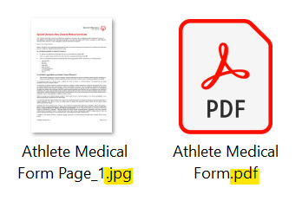
JPEG files will also appear as multiple files, or individual pages.

You can find more resources including introductory videos on the Online registrations resources webpage

