Making the most of the Events Calendar
The events calendar on the SONZ website is useful for viewing events across the country or in specific regions.
The calendar will start in ‘month’ view.
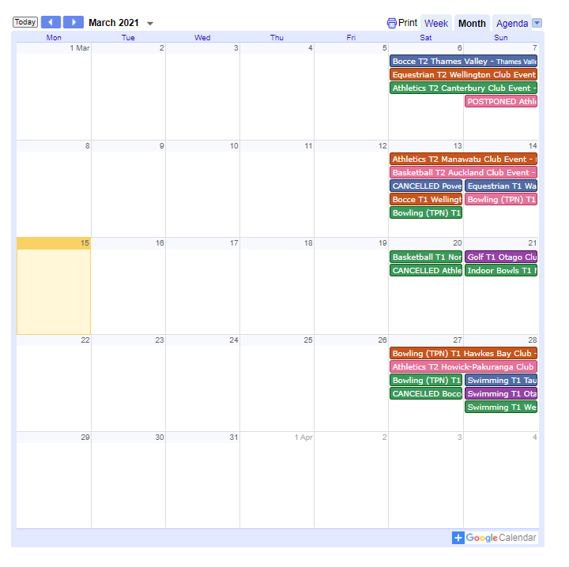
But you can also select week to view events by week, or select ‘agenda’ to view events in a list (Shown below)
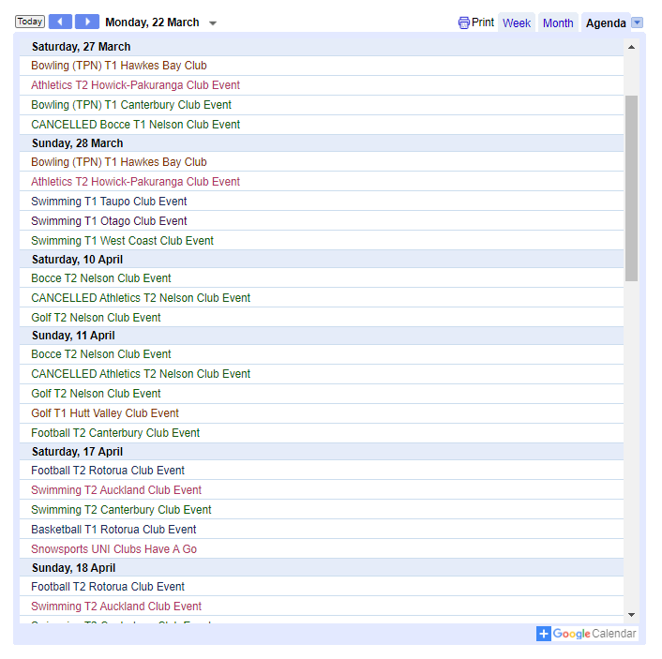
You can select the arrow to the right of agenda to show the different regions, and select which regions’ events you would like tio view.
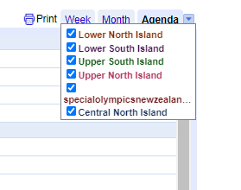
Below we have selected Upper North Island to only view events from the Upper North Island region, but you can select as many regions or as few as you’d like.
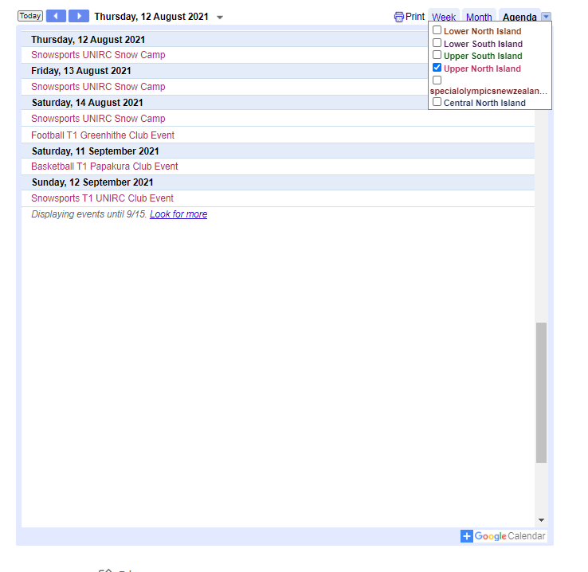

In the bottom right corner of the events calendar there is a ‘+ Google Calendar’ button.
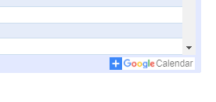
Clicking the button will open the events calendar in google calendar. This will require a google or gmail account. The google calendar has additional ways to view events, and allows an improved view of events.
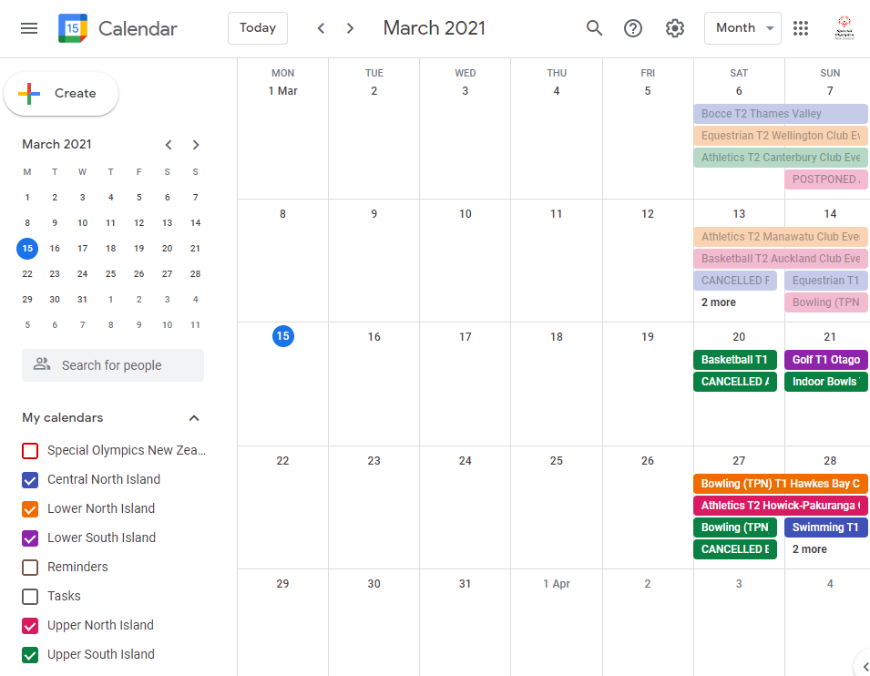

Clicking the dropdown menu will show more options for viewing events, including viewing events by Day, Week, Month, Year or ‘Schedule’. In the lower left corneryou can select which regions’ events you would like to view.
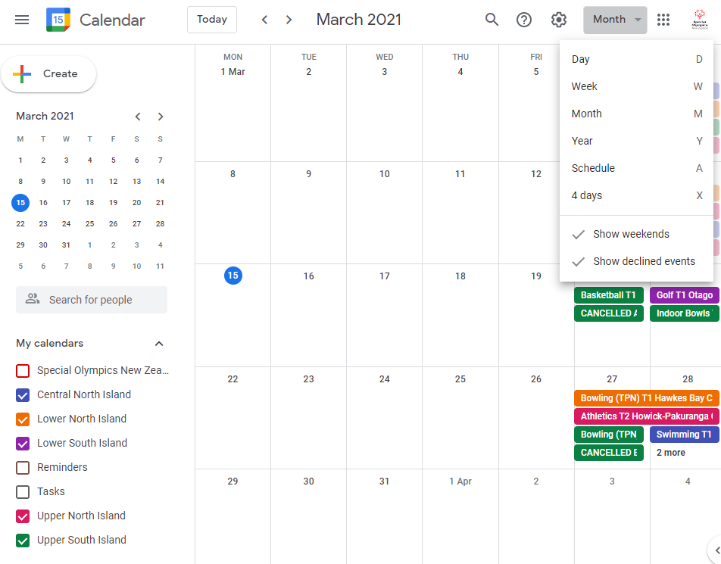

For example, below we are viewing events by schedule, and we have chosen to only view the Lower South Island Events.
