**BASKETBALL & FOOTBALL REGIONALS**

**GMS DATA ENTRY**

**MANUAL**

CONTENTS

**Round Robin**________________________________________________________________

3. On the day Scratchings

4. Results Entering

8. Results Printing

**Play Offs**___________________________________________________________________

10. Bracketing

14. Scheduling

18. Printing Match Lists

20. Printing Score Sheets

20. Results Entry for Play Offs

20. Results Printing for Awards

22. GMS Regional Team Sports Data Entry Check List

***ROUND ROBIN***

**ON THE DAY SCRATCHINGS**

* Check with the Event Manager if any scratchings have been received from Head Coaches

If there are Scratchings

* Open your Event
* Click on the word “People”
* Click on See All People in the Event

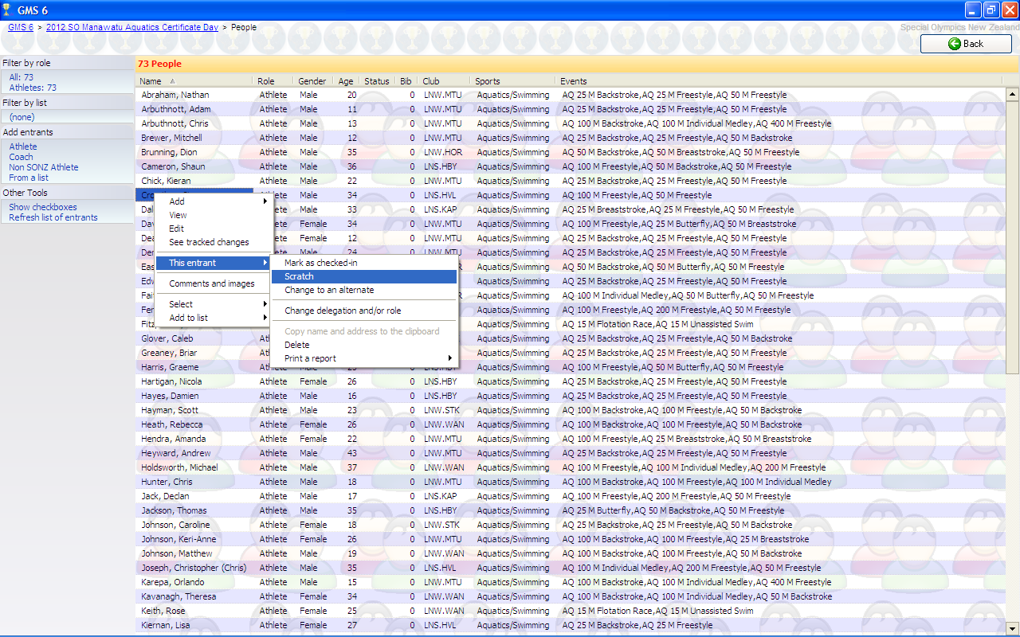

* Find the athlete who is to be scratched
* Right click on the name
* select “This entrant”
* select “Scratch”

This will then scratch the entrant from the entire competition.

Continue to follow the same process for all scratched athletes.

**Results Entering**

* Go into Events on the first screen within your event.
* Next go into the Events tab on this page, as arrowed

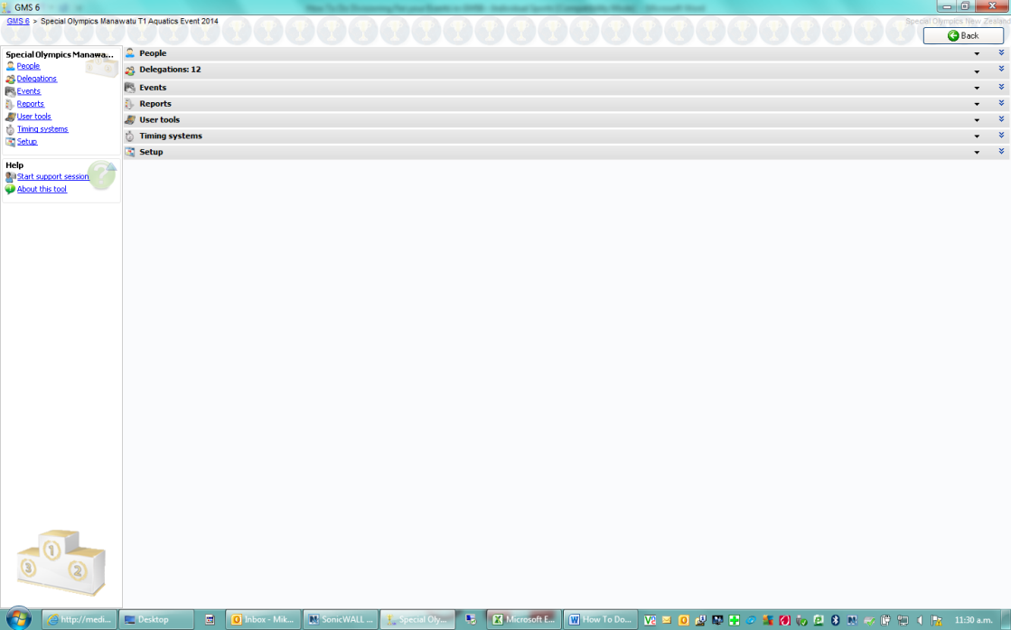

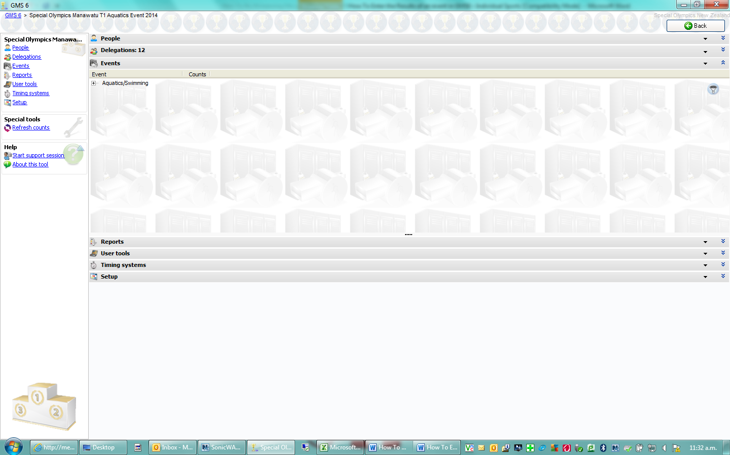

* Next click on the “+” sign beside the name of the sport
* Click on the Team Event.
* This will then take you to the next screen that will show you all the teams that are entered into your event.
* Ensure under Entries Heading (Top Left-hand side of page) round is showing

Round: Round Robin. If not click on the Blue Under lined heading that is there and click Round Robin

* under TOOLS (at the left-hand side) click on the “Bracketing/Tournaments” as shown by the arrow.

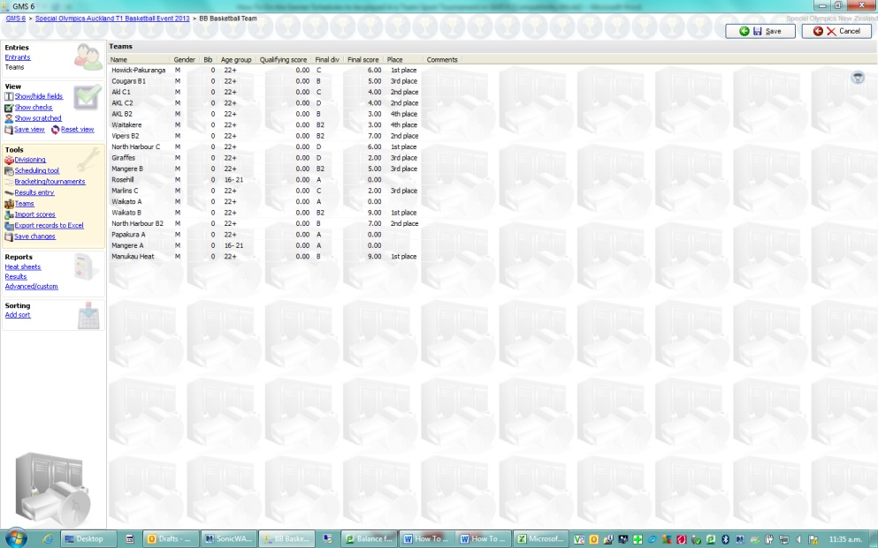

* You will see all the divisions and then if you click on any division it will then show all the games that are to be played for that division.

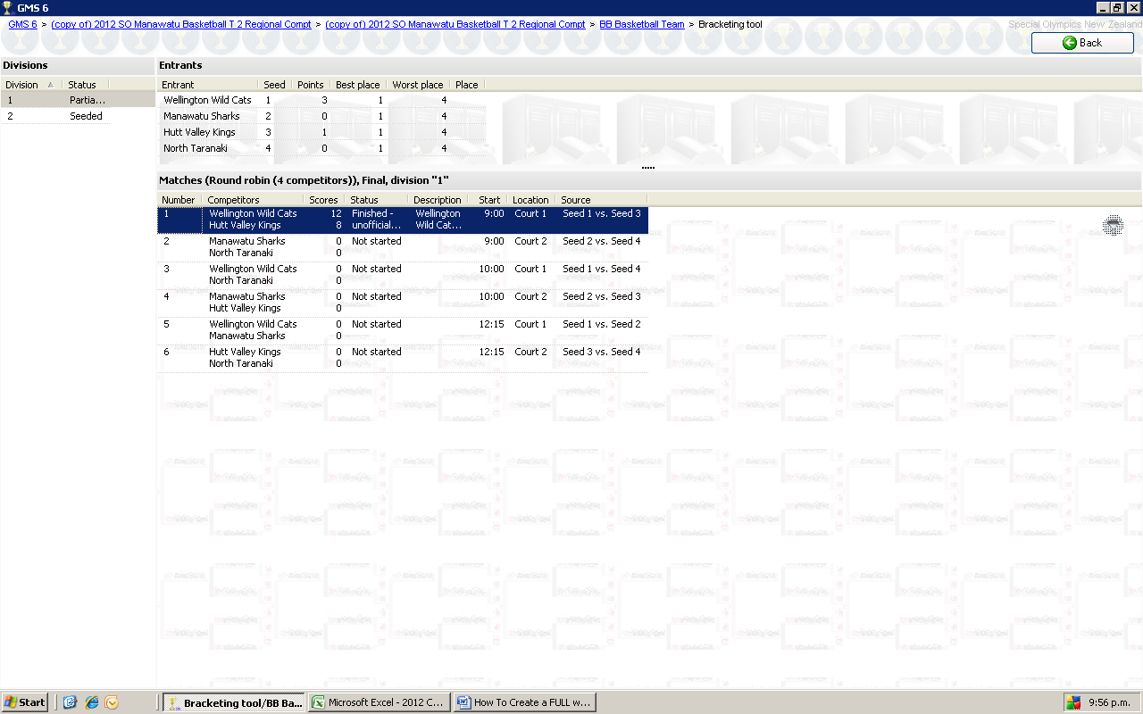

* Select the division you want to work with
* Click on the first match and a sub window will appear showing you all the information

about that game.

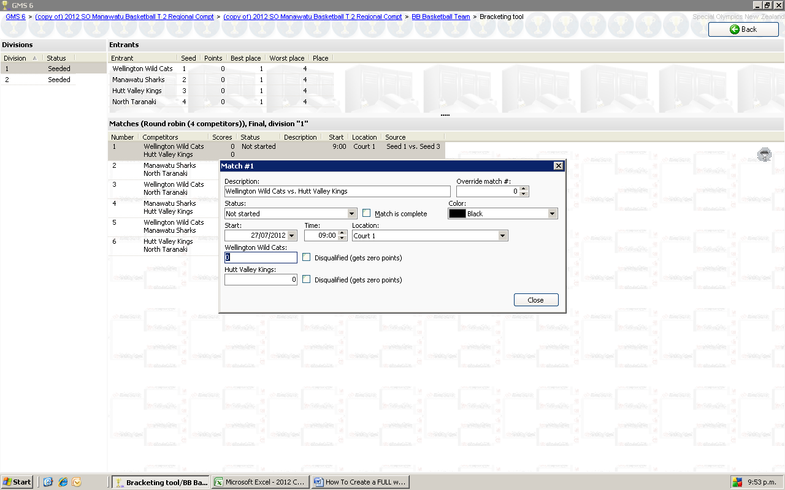

* Using the game score sheet select the name of one of the teams and enter their score into their appropriate cell and do the same for their opponents.
* Once you have entered both the result of the game into the appropriate cells tick on the cell “Match Completed” and change the status of the game in the appropriate cell the click on “Save”



shows where the Teams Scores are entered

shows where the match Status is changed using the drop-down options

shows where the Match Complete is ticked.

* All the above actions must be completed before you click **SAVE**. If you do not to these actions the points for win/draw/loss will not be assigned to either team
* Continue to do the same process for each match played until the last match and once this is completed.
* If you are in the situation of a points tie, please consult your Event Manager there should be no ties in the event.

**Result Printing**

Results are going to be printed by Round

* Once the games that have been played in this round have had there results entered.
* Click **Back**
* On Next Screen
* On Left side of Screen
* Under **Reports**
* Select **Advanced/Custom**
* **Save** Changes
* Under **Unassigned Heading**
* Select
  + Team Match List Results MASTER
* Ensure **Start Date** is on current days date
* Under **Start Times Between**
* Enter the first round **Start Time**
* Under **Events** ensure correct event you are in is showing using the drop down to select
* Select **Print** Bottom Right corner
* Ensure results for the round are showing
* Top Left Corner Select **Print**
* **Select** Printer and print of x 1 copy
* Post results for 20 Mins from the time is goes on the board record this time
* If the game goes into Protest (Your Event Manager will advise this) ask your runner to manually write “In Protest” until you are advised protest is over then change to Offical and any chnages that maybe required.
* Once the next round scores are in complete the same process except with **Start Times Between** change the end time to the followng round time . So report will show previous round score and the following score as below

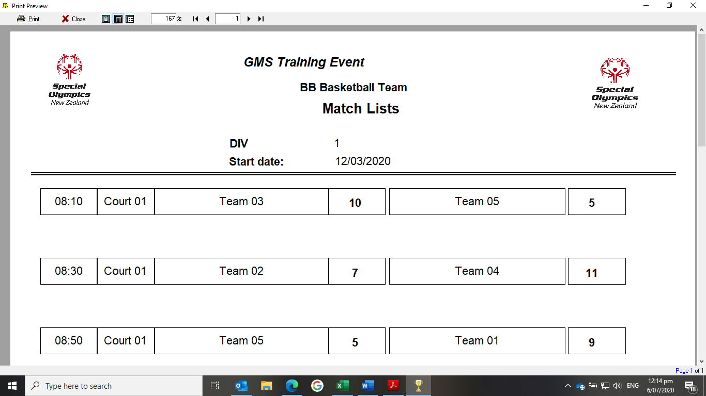

***PLAY OFFS***

**BRACKETING**

* Open Games
* Next click on the “+” sign beside the name of the sport
* Click on the Team Event.
* Ensure under Entries Heading (Top Left-hand side of page) round is showing

Round: Play Offs If not click on the Blue Under lined heading that is there and click Play Offs

* On the left-hand side of the screen under “Tools” select the option of Bracketing/tournaments, as shown by the green arrow.

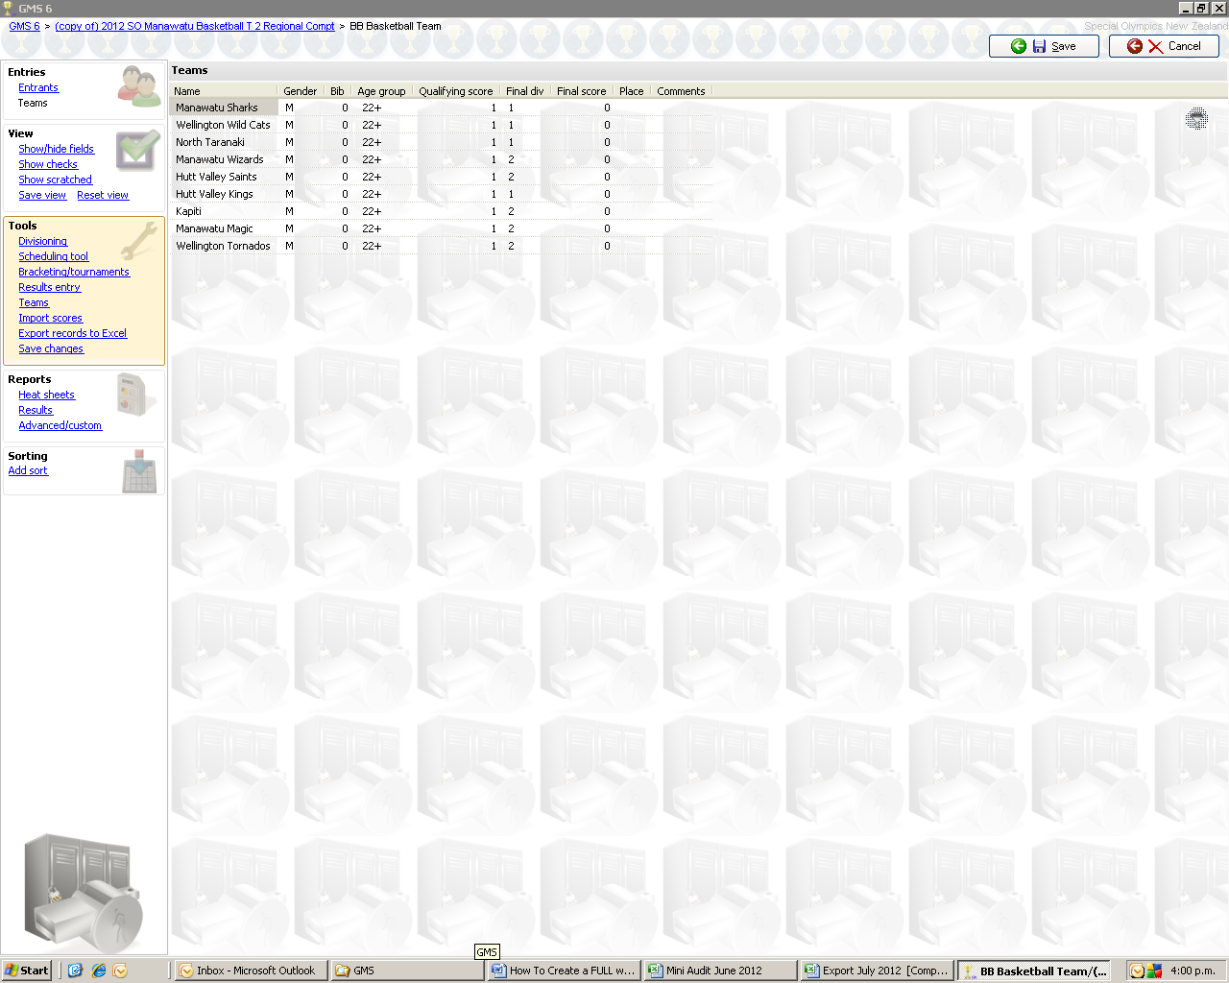

B

* This will take you to the below screen where you will begin to create the actual order of the competition games

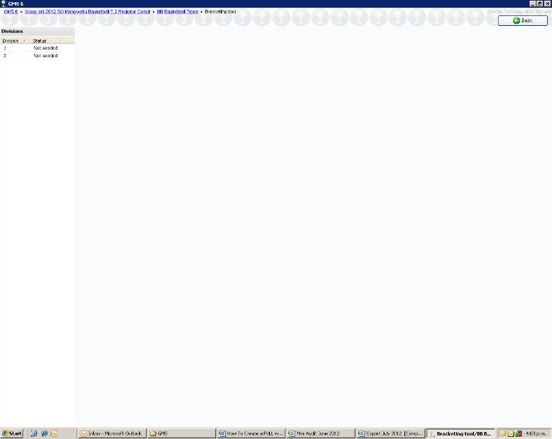

* You will note that all of the divisions currently show “Not Seeded”, as you work through each these will change to “Seeded.

(The process for bracketing is the same no matter how many teams are playing or competition format you are using.)

* Right click on the first division number and select “seed this division” from the option given (as per Green arrow).

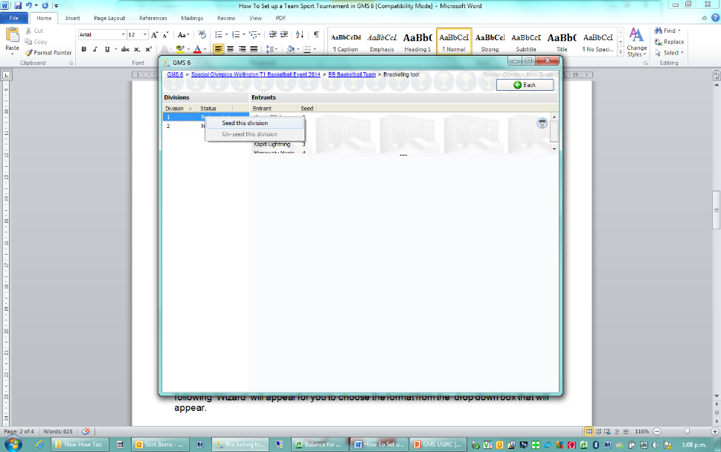

B

(This will bring up a Wizard for you to follow.)

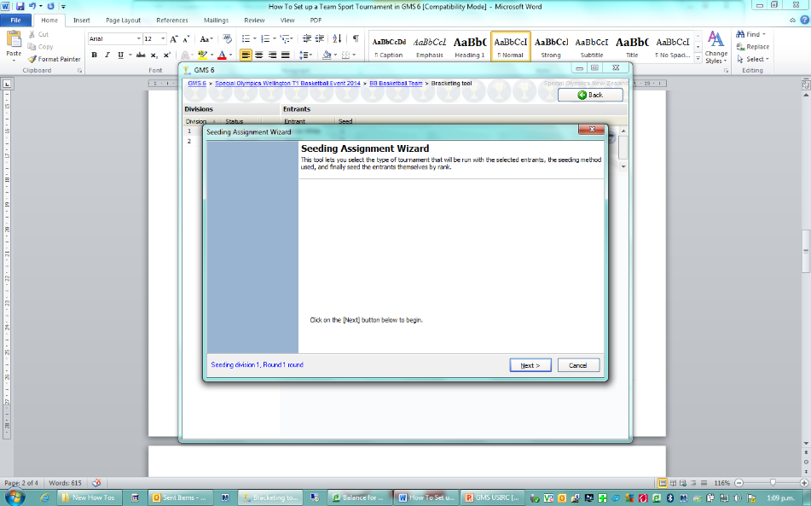

* Click NEXT.
* “Competition Format type” and go down to and click on

**Single Elimination, Knockout Final ( Number in Division Competitors) (Matches)**

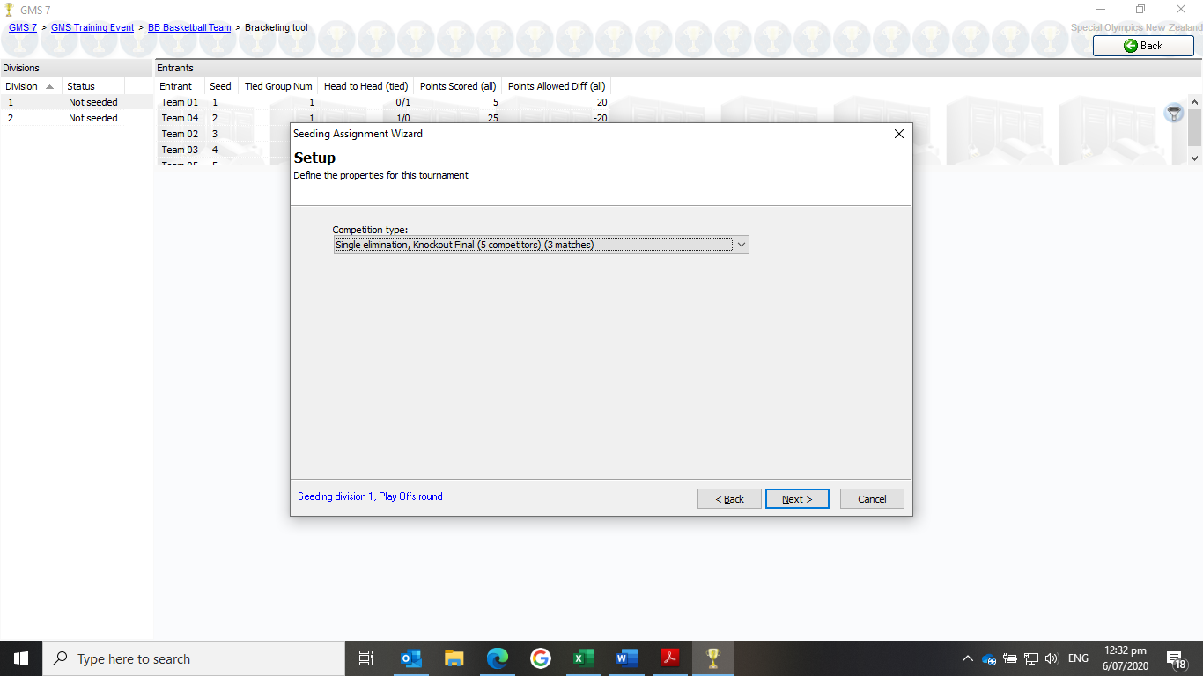

* Click Next
* **Seeding Order** 
  + GMS has automatically seeded teams based on the Round Robin Results, so you do not require to do anything on this page
* Click Next
* Click Finish

(NB // If you have an odd number in your division the lowest seed will not have a team to play in that division talk to your Event Manager and ask how they wish to deal with this)

* The screen will show the draw of who is playing who in each match

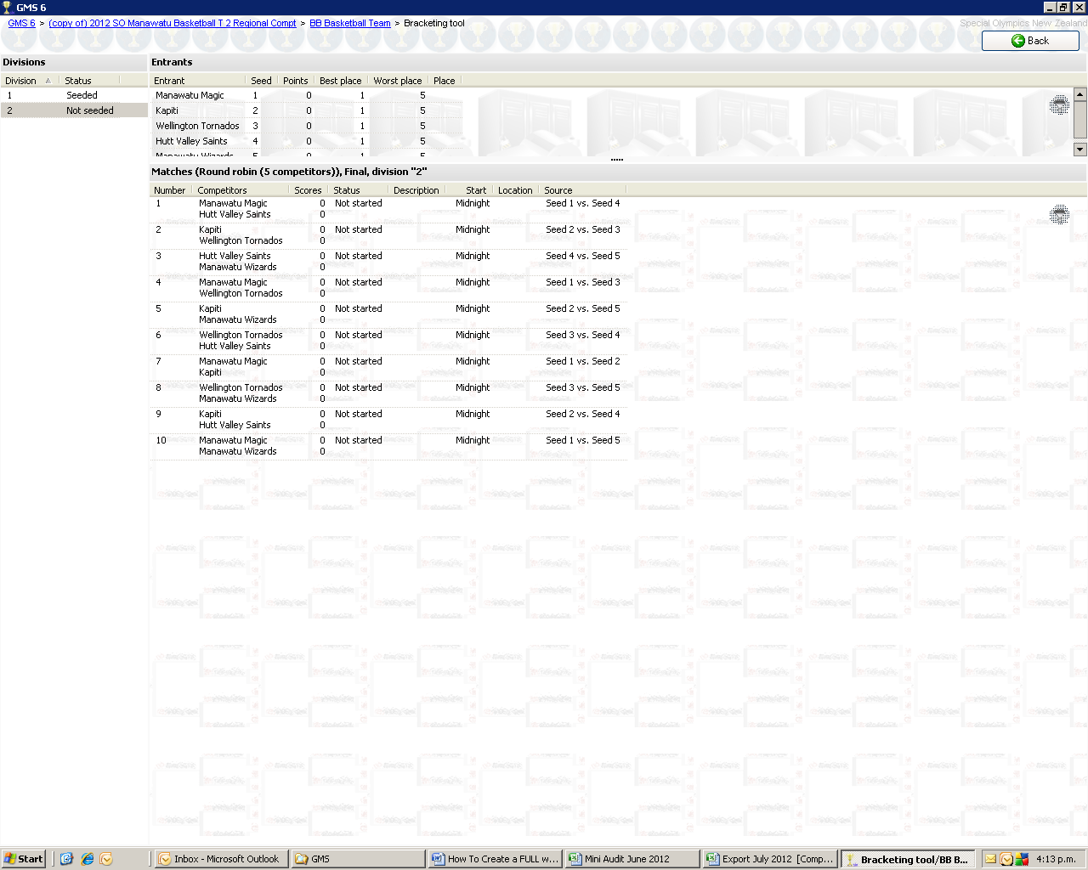

* Continue the same process for each division
* Once all divisions are seeded **Click Back**. You are now going to schedule the Games.

**Scheduling**

* On the left-hand side of the screen under “Tools” select the option of

Scheduling tool, as shown by the arrow.

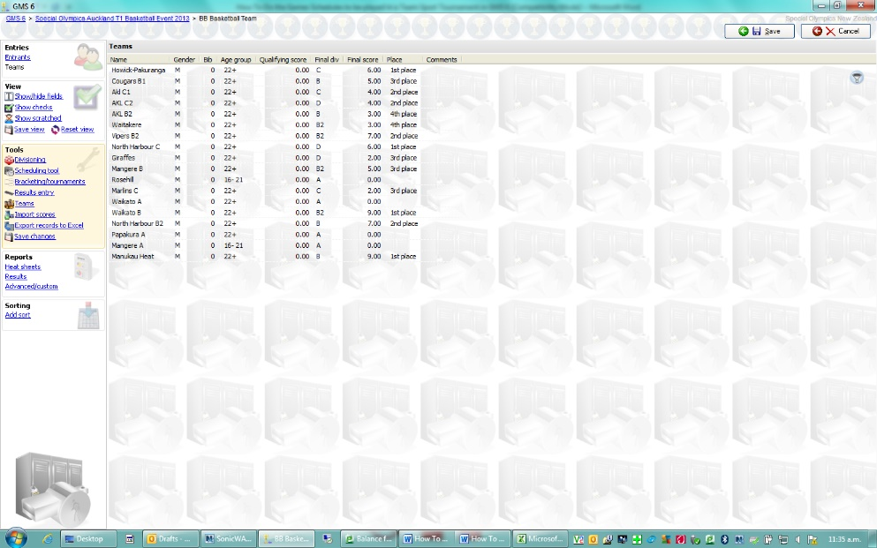

* Once you are in the next screen change the Date to the day of the Play Off Check the box next to “Show unscheduled Items” 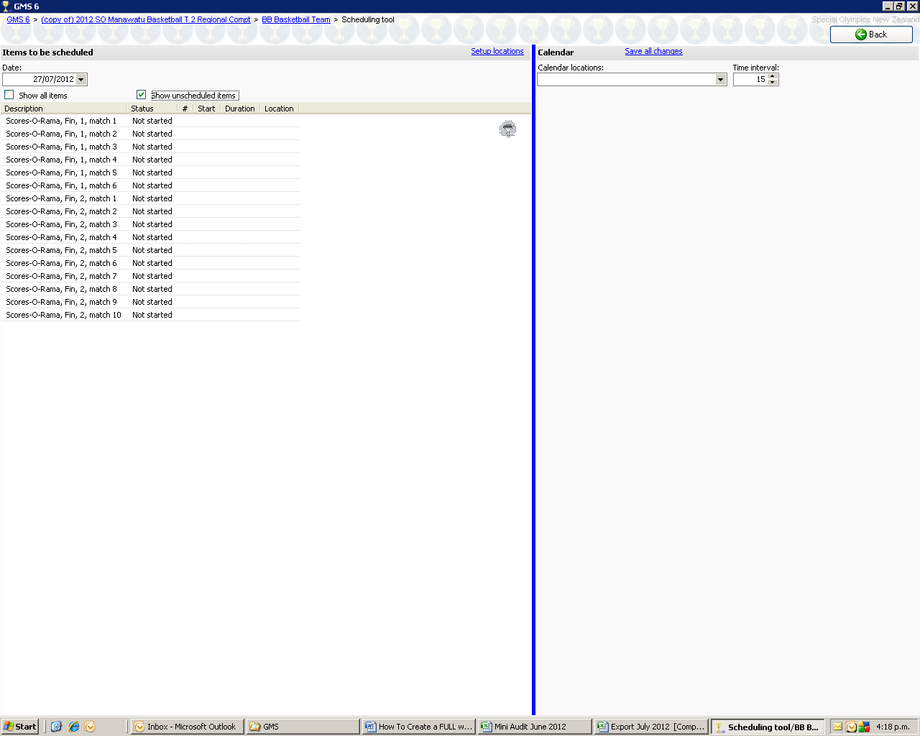
* This will now show all the games that need to be played to complete all the games in this division
* Check with your Event Manager
  + Start Time of Games
  + Length of Games
  + Any Breaks Required (E.G Lunch)
* Using the shift button select all the games in the first division (Divs and Match Numbers will all be in order eg: Match 1 - 1st v 2nd, Match 2- 3rd v 4th etc)
* Once all games in Division are blue right click on the blue area select Edit
* Check- Set Duration Box – Add time for each game EG: 00:45:00
* Check – Set Colour Box – Select any colour (This helps show the division when scheduling)
* Click Save
* Continue to set up the rest of your divisions

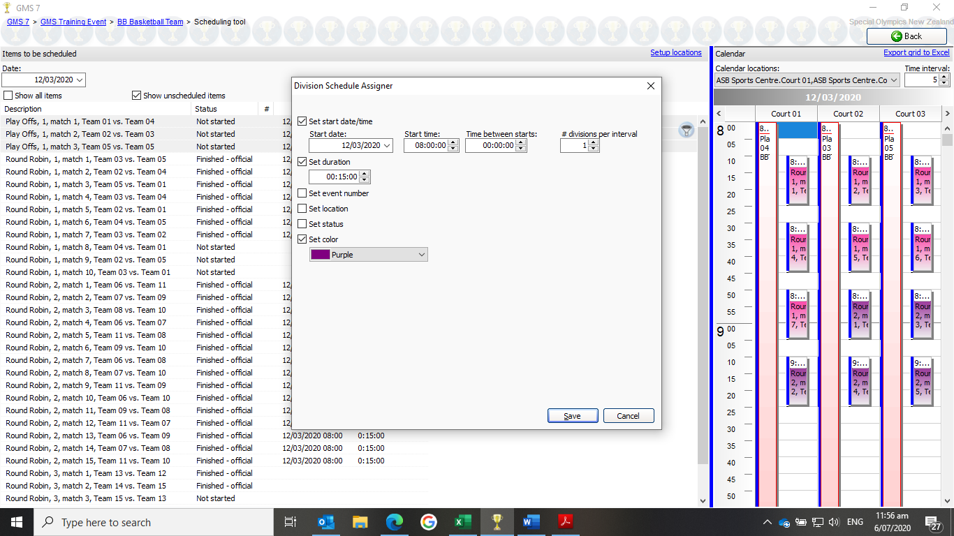

* If you now click on the “Calendar Location”, at the top right of the screen, you will now need to select ALL of the Court numbers and as you select each one you will note that the calendar is now splitting itself into separate parts with Court numbers at the top of each.

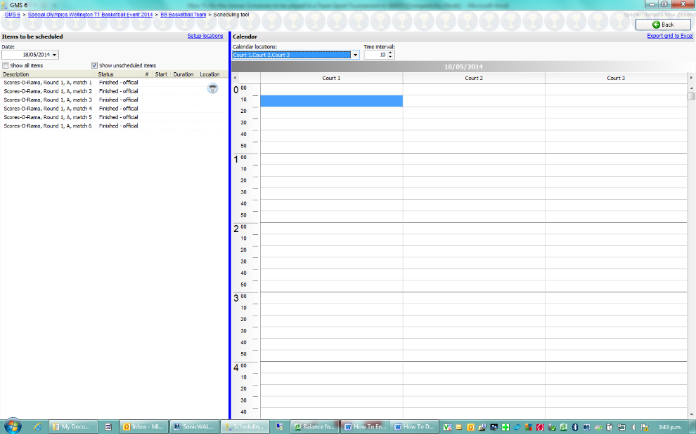

* If when you look at the screen the “Calendar” section seems to be too narrow, simply drag the Blue line (between the “Items to be scheduled” and the “Calendar”) to the left and you perform this action the space expands.
* Change the “Time Interval” in the top right-hand side of the screen (Red arrow) to 5-minute intervals. (You can change it to what works for you)
* To schedule one of your unscheduled matches, click on it (on the left) and then drag the match across from left to right and place it over the Court and start time. The once it is over where you want it to betake your finger off the mouse and it will be ‘pasted” where you dropped it

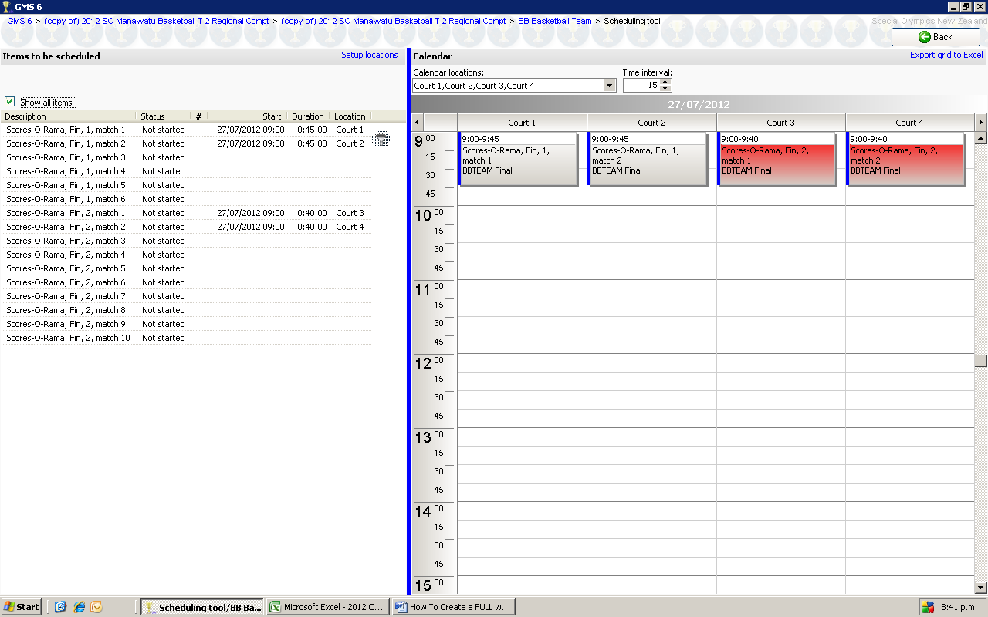

* As you build the calendar section you will note that time, date, and court # appears on the left-hand side of the screen.

Remember to leave gaps for other divisions to slot into to play their games and remember to ensure a team is not scheduled to play two games at the same time.

Continue this scheduling process until all the games have been scheduled and all the gaps filled.

If after they have all been done you can go to the top right of the screen and then click **“SAVE”.**

This will take you back one screen.

(NB// If you have a match where a team is not playing anyone it will show up with the team name twice. If they are playing a fun game, you can still schedule when this will happen.)

**Printing Match Lists**

* Left hand side of your screen under Reports Click on Advanced Custom
* Select Load Settings
* Under Unassigned Heading Select
  + Match Lists – MASTER
* Click on Select
* Start Dates – Day of Play Offs
* Statuses (no filter)
* Locations (no filter)
* Events (all)

Select Print

• Top Left Corner Select Print

• Select Printer and print required copies as per Event Managers Instrcution

* Close Window

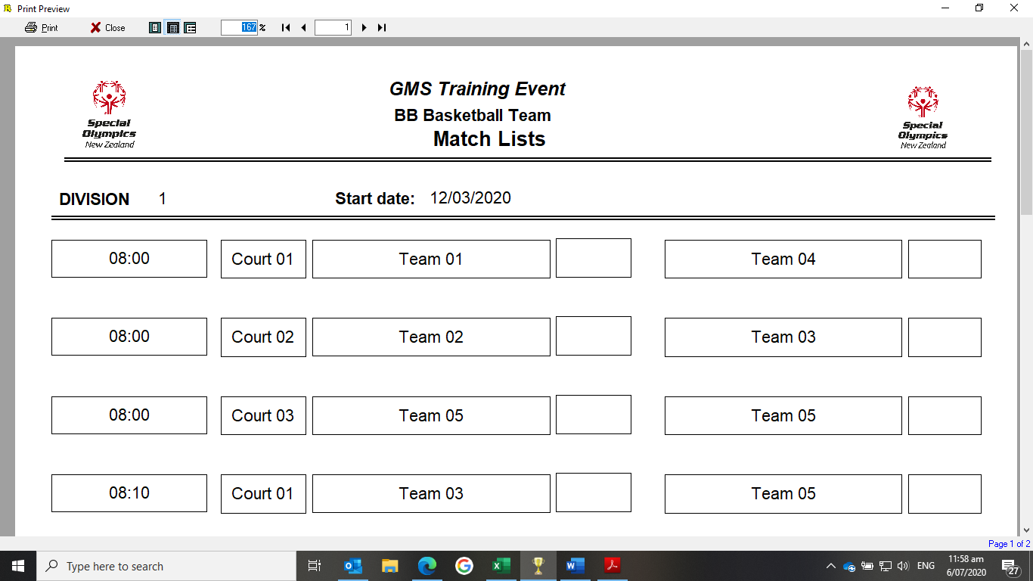

**Printing Score Sheets**

Staying on the Advanced/custom reports page

• Select Load Settings

For Basketball

• Under Basketball Heading Select click on

* + BBL Game Score Sheet MASTER

For Football

Under Unassigned Heading click on

* + FB Match Score Sheets MASTER

• Click on Select

• Start Dates – Day of Play Offs

• Statuses (no filter)

• Locations (no filter)

• Events (all)

Select Print

• Top Left Corner Select Print

• Select Printer and print required copies as per Event Managers Instrcution.

• Close Window

***Result Entry and Result Reports for Play Offs***

* Follow Same Process as resulst entry for Round Robin round
* After round has been played and results enter post results (using same reports as round robin ) for 20 mins.

***Results Printing for Awards***

Once Division is completed Final Results need to be printed for Awards

* On Main Event page (when you first open the Games)
* Under **Reports**
* Select **Event Results Report**
* Under Tools
* Load Settings
* Under **Unassigned Heading** Select
  + Teams Finals Results MASTER
* Ensure under Events is showing the correct event you are wanting to print
* Select **print** bottom Right.
* Ensure all teams have a place
* Top Right
* **Print**
* Confirm with Sports Venue Manager How many copies you need.

***GMS REGIONALS TEAM SPORTS DATA ENTRY CHECK LIST***

On the Day Scratchings done



Results entry for Round Robin

Results Report Printed and Posted for 20mins after each round

Play Offs Bracketed

Play Offs Scheduled

New Match Lists Printed

New Score Sheets Printed

Results entry for Play offs

Results Report printed and posted for 20mins after each game

Awards Reports Printed