GMS 7

Sports Results Entry

How To

Individual Sports
(Athletics,Bowling,Swimming,Equestrian,Golf,Alpine Sports)

Importing Local Copy of GMS
Before you can complete results entry for GMS you must have a local copy of GMS downloaded and saved to your desktop for use.
Note: You will need an internet connection to download and set up GMS on your computer (and to import the games files), however once this has been completed you will not require internet at the event (unless using a wireless printer).
- Open web browser and type: (chrome is best)
  - www.box.com
- Login with:
  - Username: info@specialolympics.org.nz
  - Password: 5p3c1@l
- Locate the folder “gmslocal”
- Right click on the folder
  - Select “download”
  - Select “okay”
- A dialogue box will appear at the bottom of the page
  - Select “Save as”
  - You will need to save the file to your c:drive
- Once downloaded another box will appear
  - Select “open”
- This will take you to a zipper folder
  - Right click on zip folder
  - Select “extract files here”
- The event folder will now appear
  - You will need to scroll down to find the file (the GMS7 icon shows as a trophy)
  - Right click on icon
  - Select “send to – desktop”
- GMS7 Icon will appear on your desktop
- Double click on the icon
  - A box will appear
  - Select “connect”
- You are now in your local copy of GMS
- No events will show yet.

Importing Games File in Local Copy GMS
Before you can complete results entry for GMS you must download the Games File (which will be sent via email as a zipped file)
Note: You will need an internet connection to import the zipped file into your local copy of GMS on your computer, however once this has been completed you will not require internet at the event (unless using a wireless printer).
- Regional Sports Coordinator or GMS Administrator will send you an email with a zipped file required for data entry at the event
- Save the zipped file on to your computer (desktop or somewhere you know where it is)
- Open your local copy of GMS
- Select “GMS Transfer” from the front screen once GMS opens
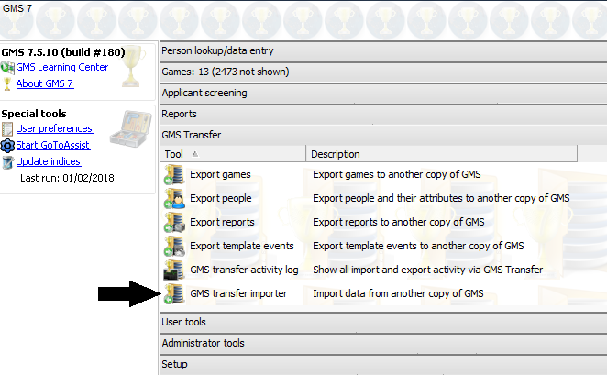
- Select “GMS Transfer Importer”
- Select the zipped file you wish to import
  - Select “open”

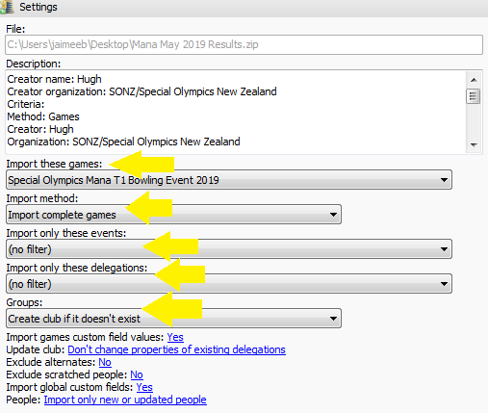
- You will need to identify:
  - Import these Games – The correct Name of the games you are wishing to import
  - Import Method – Import Complete Games
  - Import only These Events – Right Click Select All
  - Import Only These Delegations – Right Click Select All
  - Groups – Create club if it doesn’t exist
  - Rest of the statements leave as is
- Click “run”
  - A report will run which will mean that the games has been successfully imported
  - Click “close”
- Click “back” (top right-hand corner)
  - You will now be on the main screen
  - Select your games
    - Event will now be showing
- You are ready to use GMS at your event
- Complete the above steps to import any results reports you may require for your event (these will be sent via zipped file in email)

On the Day Scratching’s

Sometimes this does happen, athletes are unwell or unable to travel to the event. In order to ensure GMS results are a true and accurate reflection of the event that has taken place (qualifying period in particular) we must scratch athletes from the event if they did not attend. No athletes shall be entered on the day of the event (all entries must be received and processed no later than three weeks prior to the event)
- Check with Event Manager re any athletes who have been scratched from the event
- Open your event in GMS
- Click “People”
  - Click “See all people in Event”
- Find athlete who has been scratched
  - Right click on the name
  - Select “This entrant”
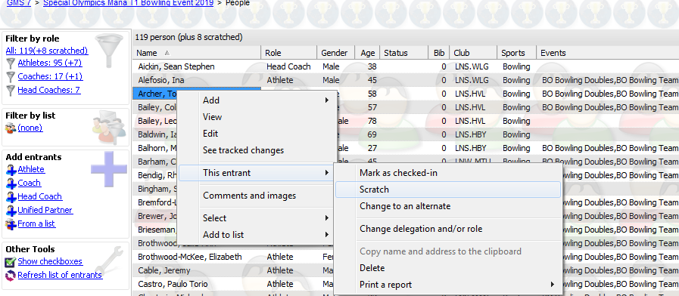
  - Select “scratch”
- This will scratch the entrant from the whole event
- If you need to scratch the athlete from a single event i.e. 100m Run
  - Go into the individual event
  - Repeat step 4 to scratch athlete from the individual event (this will not affect other events they may participate in throughout the day)

Changes to relay teams (People and Positions)
To remove an athlete from a relay team
- Open the Event
- Click “See all People”
- Click on Athletes Name
- Click on “Relay Event”
- Right Click “Scratch”
- Select “Exit and Save Changes” (Top right screen)
To add an athlete to a relay team
- Open the Event
- Click “See all People”
- Click on Athletes Name
- Go to “Events” and right click anywhere in box
- Select “Add Event”
  - Select “Athletics Track and Field”
  - Select the Relay the athlete will be going in to (from drop down)
  - Select the Team position
  - Click save
- Select “Exit and Save Changes” (Top right screen)

Results Entry
- Open GMS
- Select your event under the “Games” Tab i.e. “Special Olympics Mana T1 Bowling Event”
- Select “Events”
  - Select “+” to choose which event you want to enter results for
- Under “Tools”
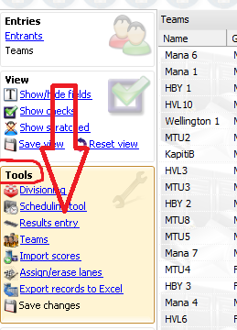
  - Select “Results Entry”
- Change the “division status” change from “not started” to “Finished – Unofficial” to allow for protest period
- You can now enter the individuals scores in as received from officials.

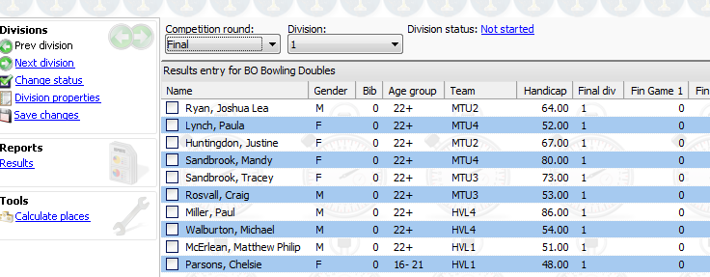

- Once you have entered all scores for the division
  - Select “calculate places”
    - This will determine 1st, 2nd, 3rd etc.
- Repeat steps 5 – 7 until all divisions are complete
- Under “reports” TAB
  - Select “results”
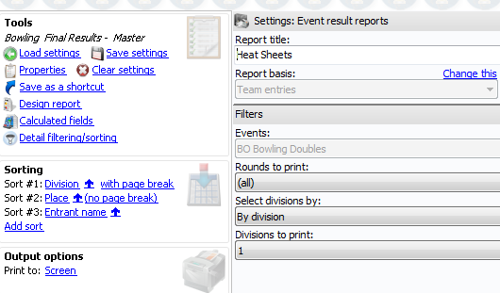
  - Save changes
- A screen will appear
  - Select the Report you require:
    - Athletics
      - AT Field Final Results
      - AT Track Final Results
      - AT Relay Final Results
    - Equestrian
      - EQ Final Results (individual)
    - Golf (only use the multiple round report if event is hosted over two days i.e. scores will be recorded for both days)
      - L1 Single Round – Final Results Master
      - L1 Multiple Round – Final Results Master
      - L2 Single Round – Final Results Master
      - L2 Multiple Round – Final Results Master
      - L4,5 Single Round – Final Results Master
      - L4,5 Multiple Round – Final Results Master
    - Swimming
      - SW IND Final Results – Master
      - SW Relay Final Results - Master
    - Tenpin Bowling
      - “Bowling Final Results – Master”
- If screen does not appear with list of reports
  - Select “Load Settings” (top left-hand corner)
  - Select the report you require
- Rounds to print
  - Select the divisions you wish to print
- Select Print
  - Make sure your printer is set up as default setting in computer
- Now you can post the results
  - For coaches to see and award presentations

At the end of the Event

You are required to send a zipped file of the event back to your local RSC so the results can go into the National Office copy of GMS.

Exporting a Copy of the Event to a Zipped File

After you have finished with your event and everything has been completed then please go back to the start of GMS (as per when you first go into the programme) so we can go through the exchange process to transfer a copy of the completed games back.

- Go into GMS Transfer

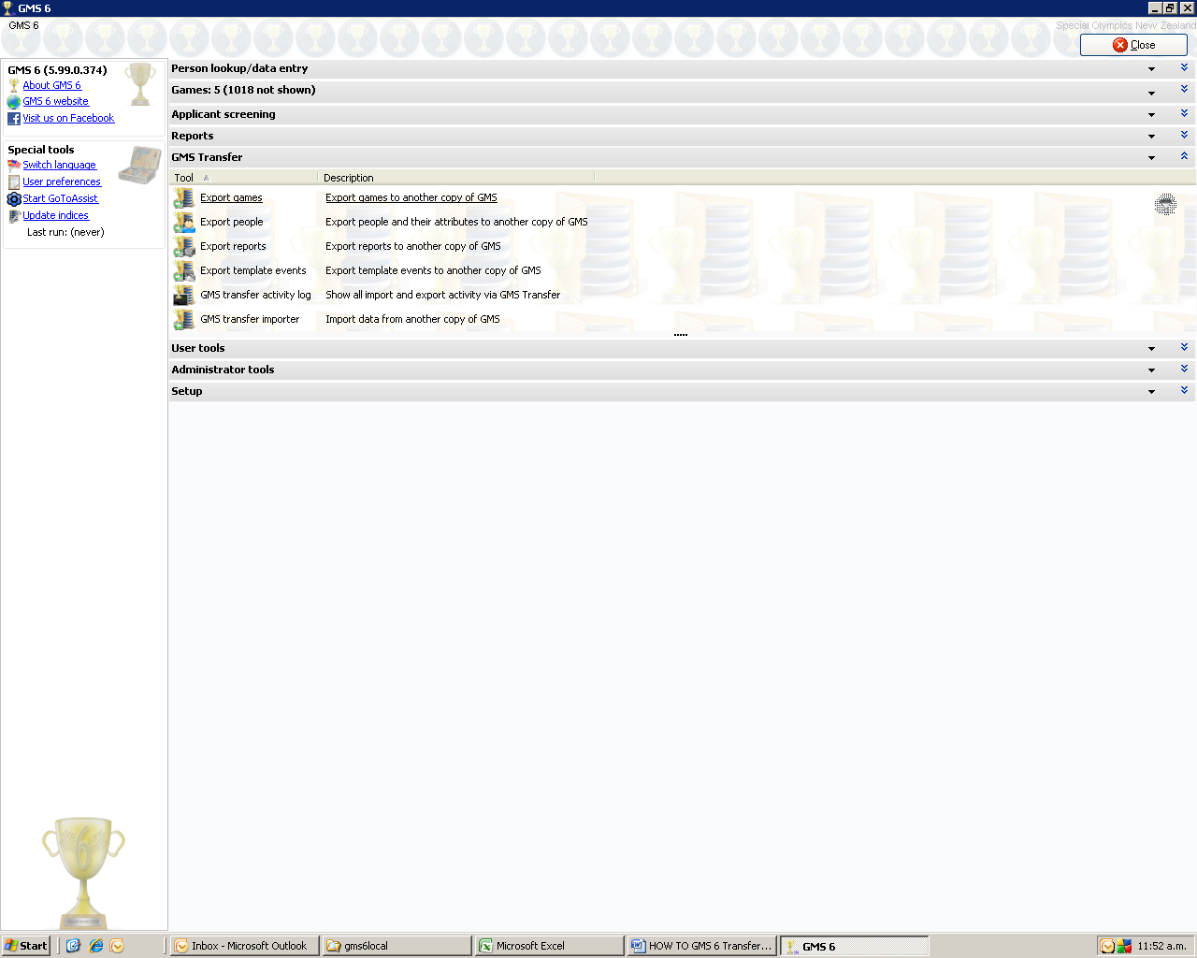

Next click into the top option given Export Games – Export games to another copy of GMS

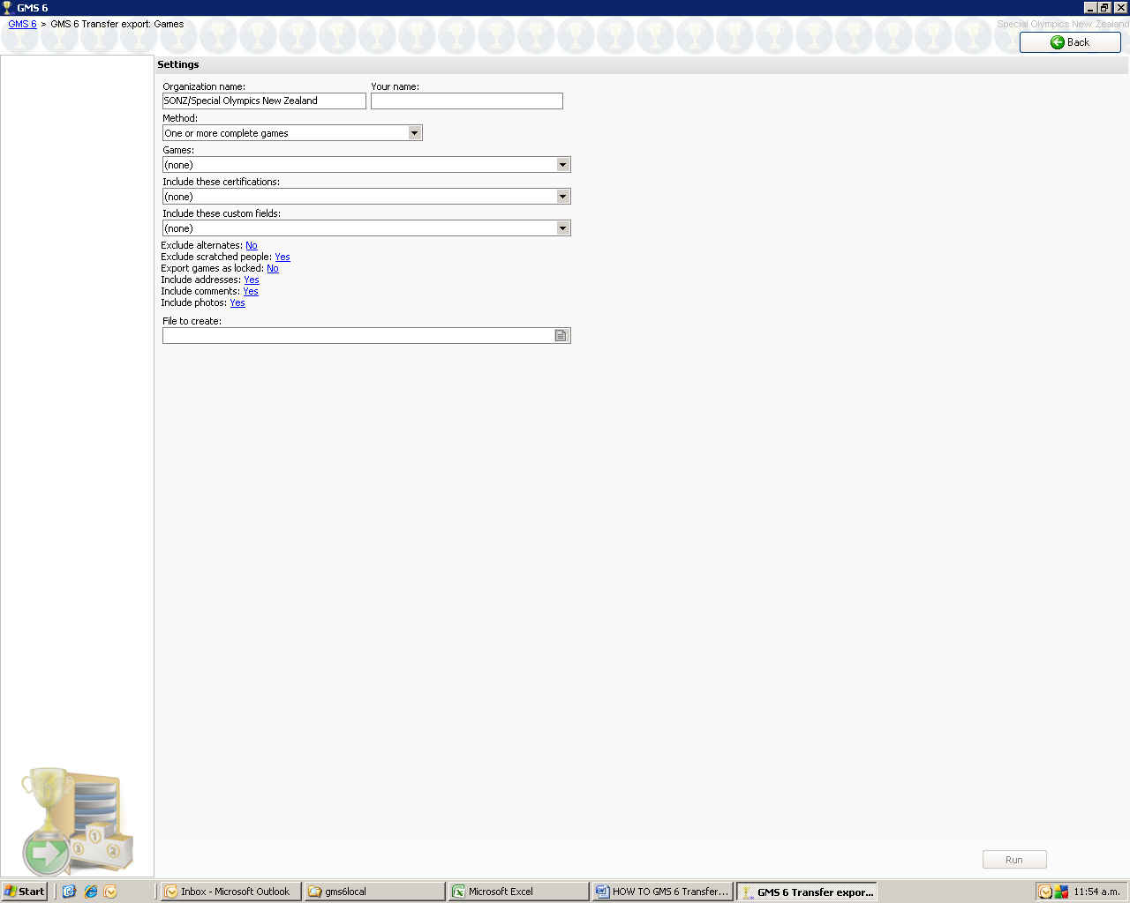
- On the top right cell enter your name, as arrowed in Red.
- The system should default to One or More Complete Games in the Method cell. If it doesn’t then please change it by selecting it from the drop down options given.
- Next, select the Games that you have been working with from the options given in the drop down box, as arrowed in Blue
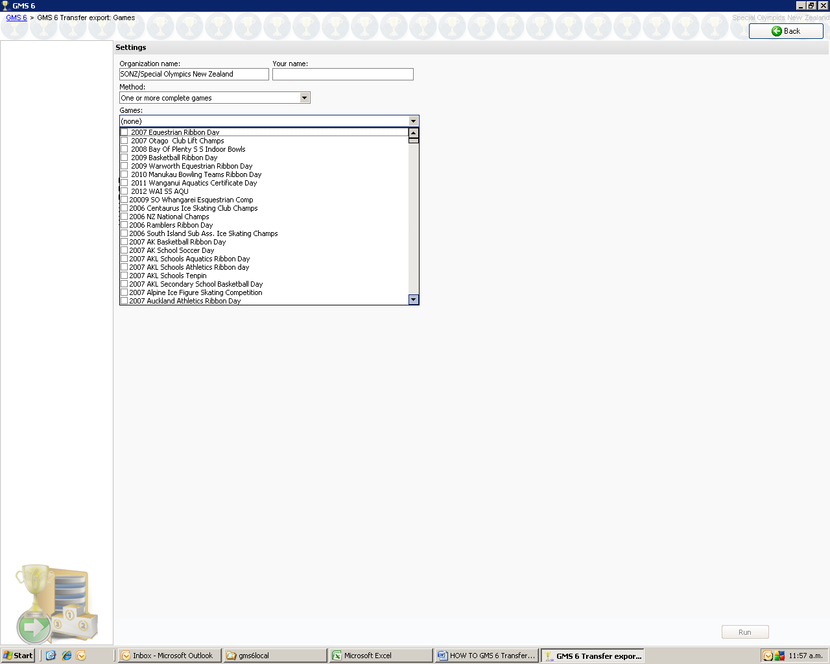

- Next just leave the “Types of certifications to export” cell.
- Next for almost all sports the Custom Fields to export can be left as “NONE” but if you are
Other fields can left as they are

Now you will need to decide where you want to save the transfer file and what name you intend to give it

Save it to whatever you want to BUT remember what you’ve called it and where you’ve saved it.

Click on the box as indicated by the arrow and the following sub screen will appear.
(This is where you need to save the report and give it a name that you will know later on.

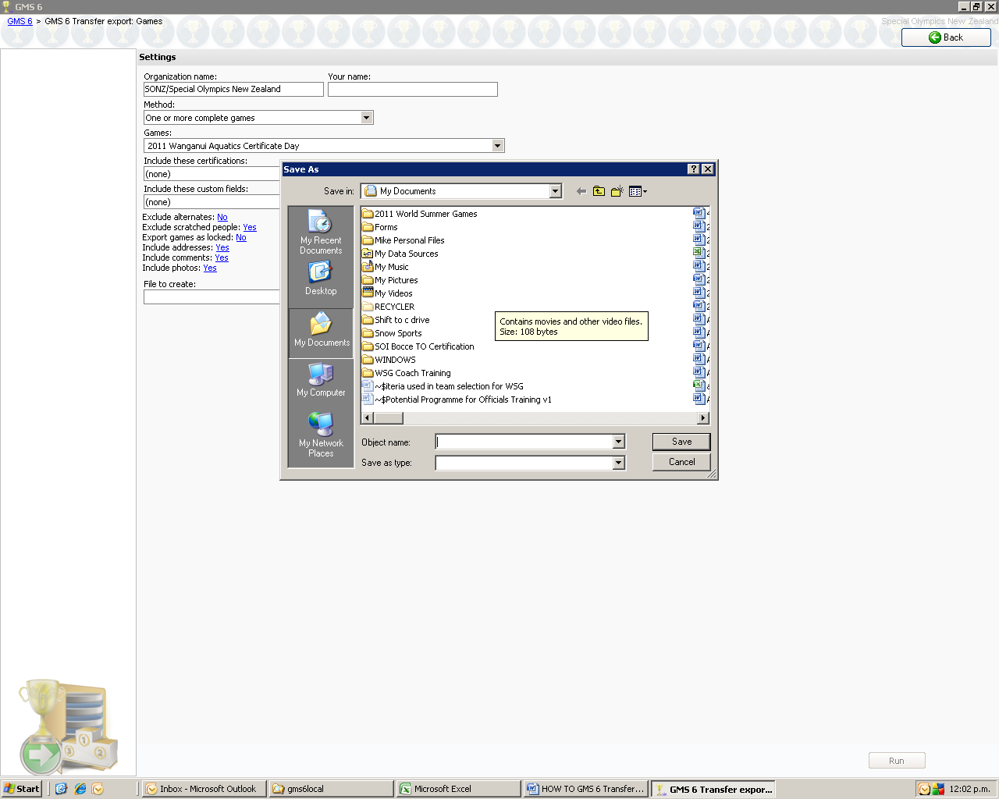

Once you have given ti a name Click “Save” at the bottom right of this sub screen, as arrowed.

Next click RUN at the bottom right of the GMS screen

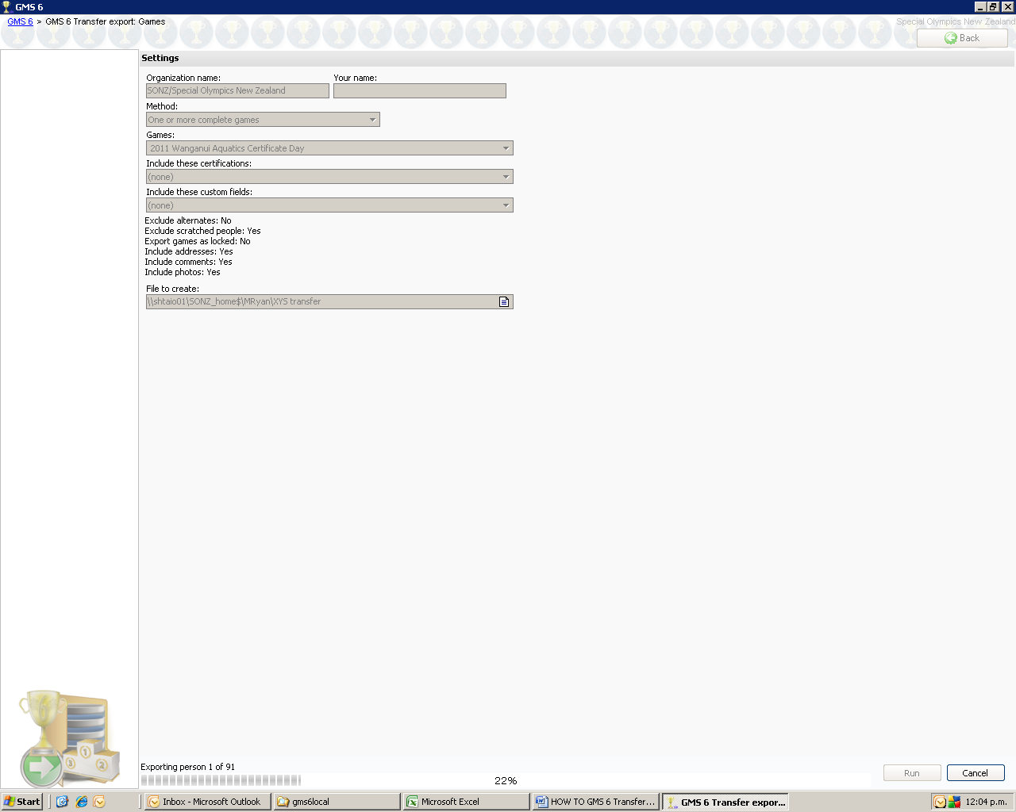

GMS 6 will then create the new file and get all the information from the main file and create a new one.

You can follow it by looking at the bottom your GMS and it will tell you where it is at, until it is finished & when it will tell you “FINISHED” and produce a report of the transfer

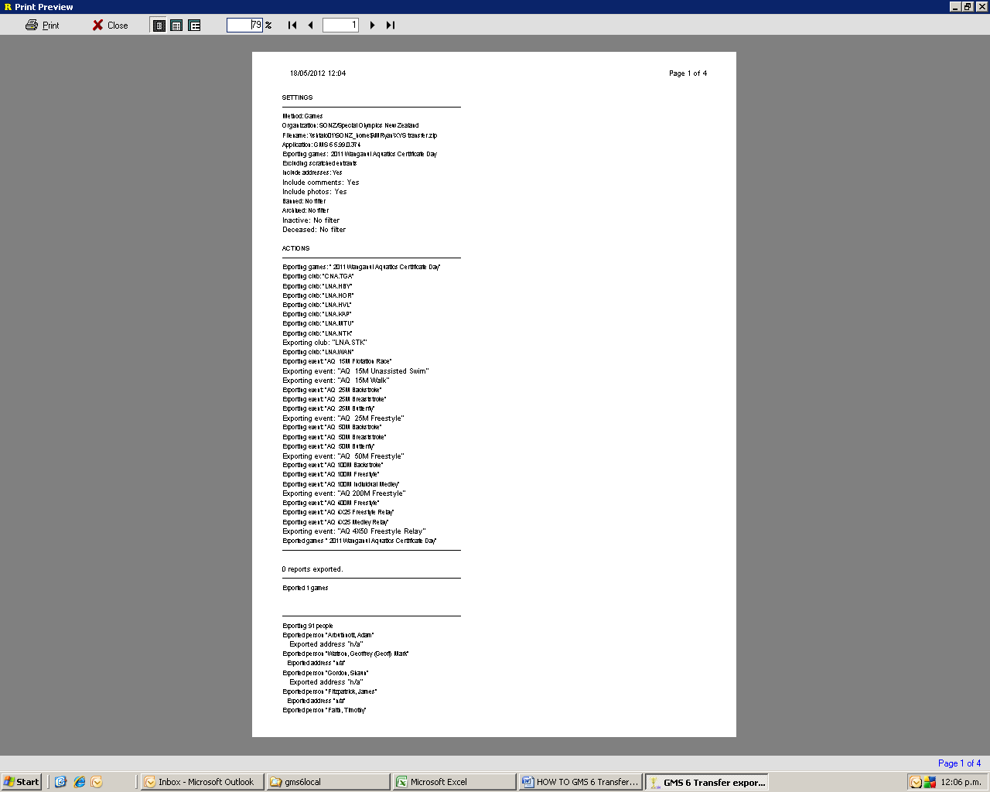

This is your confirmation that the file has been exported and ready to sent to National Office or your Regional Sports Coordinator.

Select Close at the top left hand side of the screen and this will close the export reports page.
- You can now email the zipped transfer file back to you local RSC

NOTES

